LECTURE # 04 PROBABILITY:
Discrete probability
If we have a variable that takes on a discrete set of outcomes, such as a coin (heads
or tails) or a pair of dice (numbers 1-12), then a probability may be assigned to each
outcome.
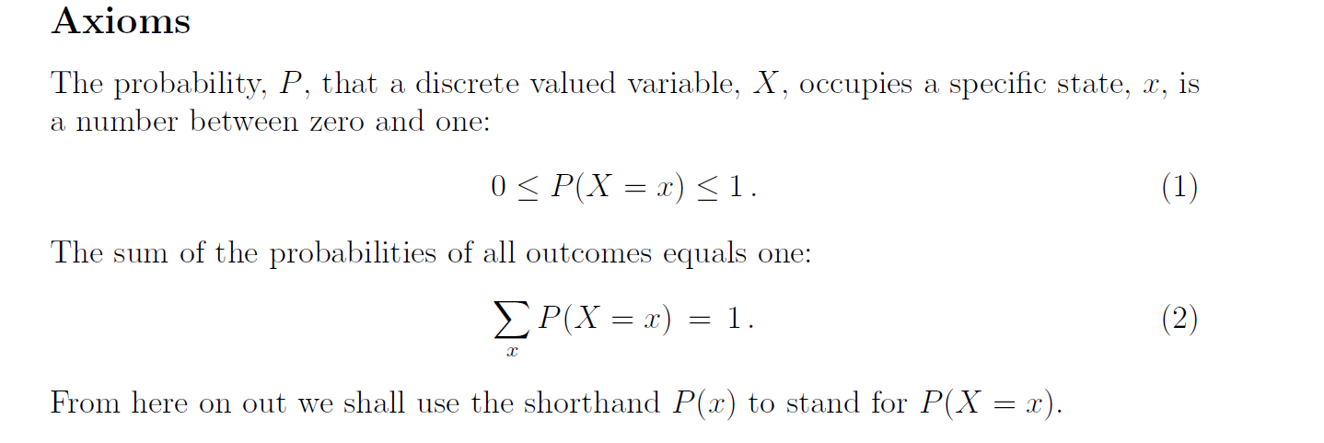
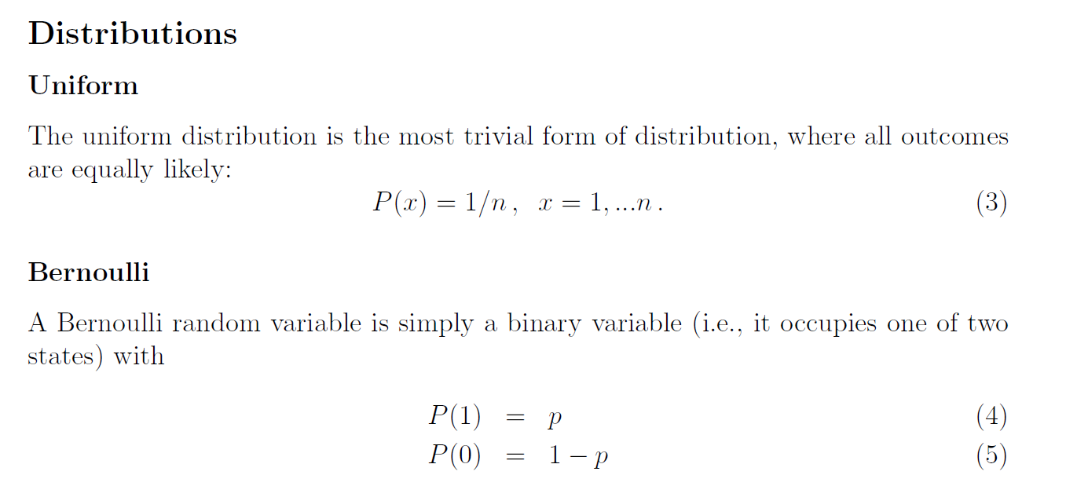

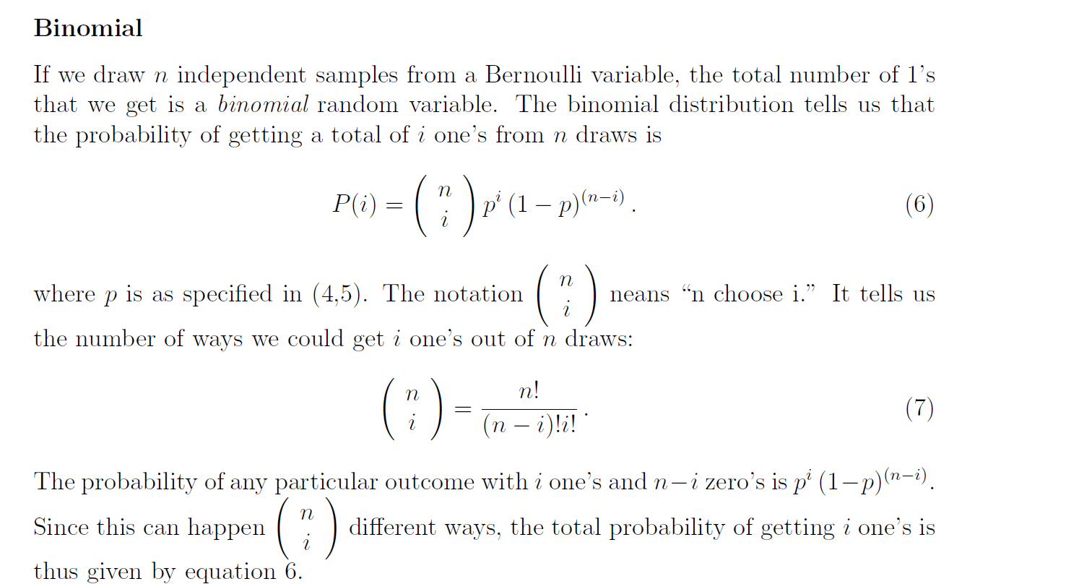
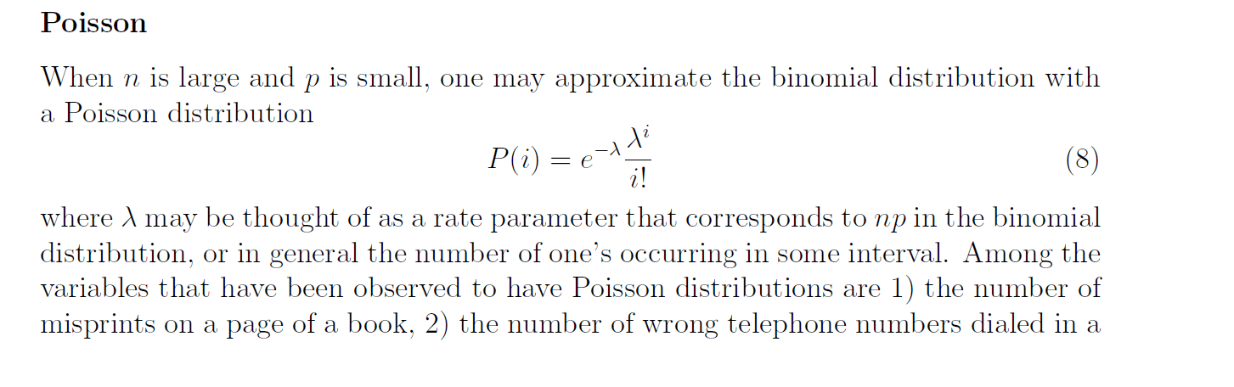
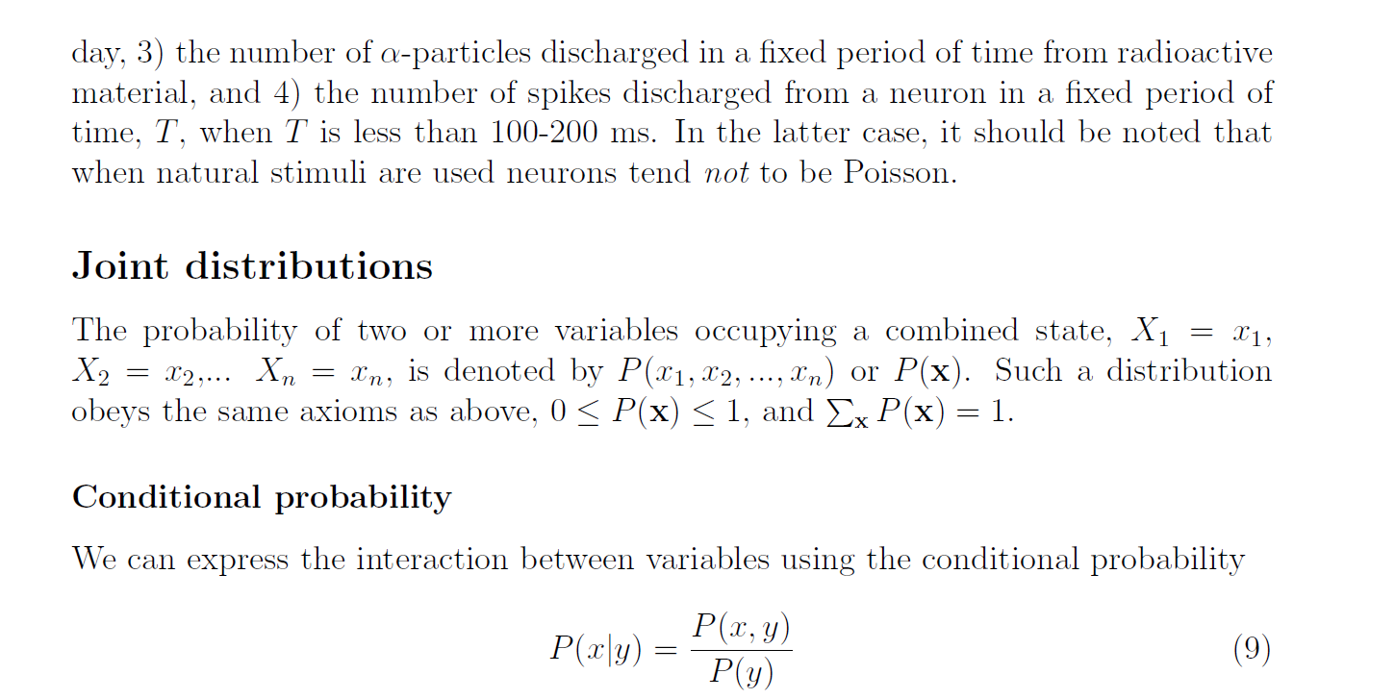
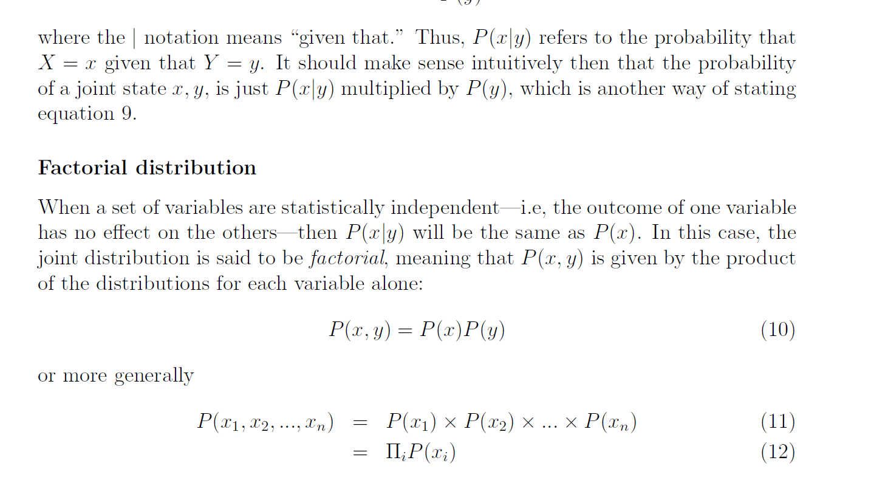
Continuous variables
A variable that takes on a value along a continuum, such as voltage or light intensity,is assigned a probability density function, or p.d.f., which measures the amount of probability per unit of the variable. For example, the p.d.f. for the voltage on a car battery, p(V ), might be a bell-shaped function that is peaked at 12 volts with some spread on either side. The value of the function at a given point does not denote the probability of being exactly at that voltage (since the continuum of voltage is infinitely divisible), but rather the “probability per volt.” If you want to know the probability of the voltage being found between 11.9 and 12.1, then you would integrate p(V ) over that interval:
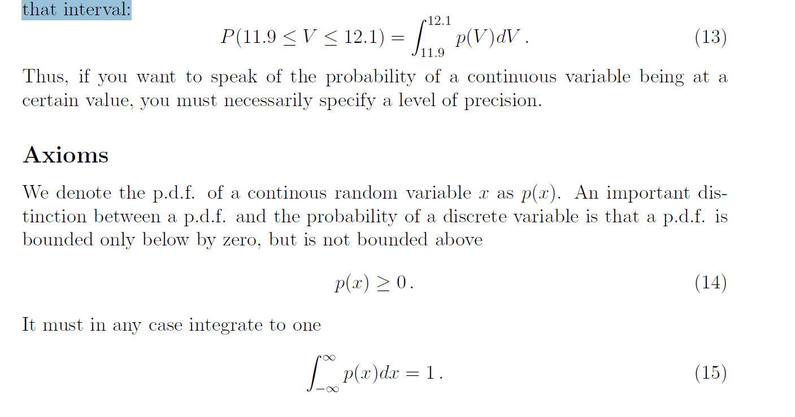
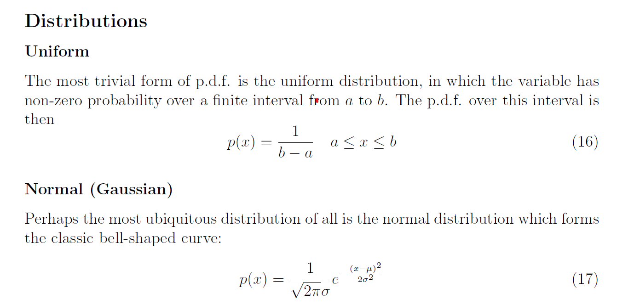
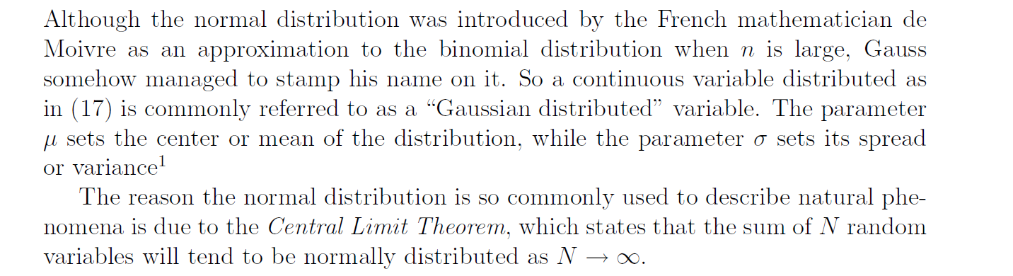
FOR NORMAL :
Normal Distribution (Gaussian Distribution):
The normal distribution, often denoted as N(μ, σ^2), is a continuous probability distribution characterized by its classic bell-shaped curve. In the equation you provided:
- p(x) represents the probability density function (PDF) of the normal distribution.
- μ (mu) is the mean or average of the distribution, which sets the center of the bell curve.
- σ (sigma) is the standard deviation, which controls the spread or width of the bell curve.

Example: Heights of Adult Population
Let's consider an example to illustrate the normal distribution. Suppose we are interested in the heights of adult individuals in a population. We collect data and find that the heights follow a normal distribution with a mean (μ) of 170 centimeters and a standard deviation (σ) of 10 centimeters.
Central Limit Theorem: The passage also mentions the Central Limit Theorem, which is a fundamental concept. It states that the sum of N independent and identically distributed random variables, as N becomes large, will tend to follow a normal distribution, regardless of the original distribution of those variables. This property makes the normal distribution extremely valuable for modeling various natural phenomena and for statistical inference.
SUMMARY: the normal distribution is characterized by its bell-shaped curve, controlled by the mean (μ) and standard deviation (σ). It is widely used in statistics due to its prevalence in natural phenomena and its emergence from the Central Limit Theorem. The example of height data illustrates how the normal distribution can be applied to model real-world data.
FOR UNIFORM: This means that every value within the interval [a, b] is equally likely to occur.

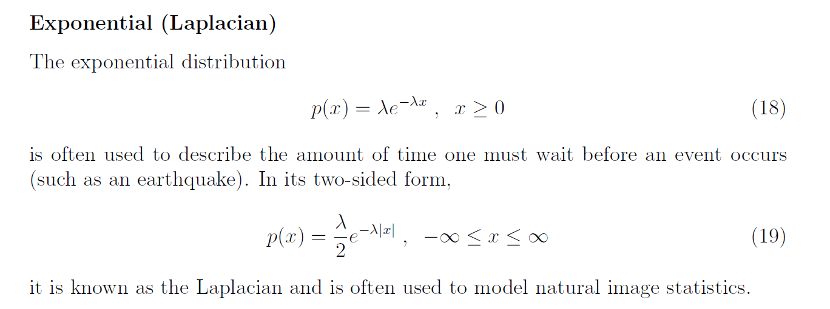
HOW THINGS SHIFT OR VARY, ESPECIALLY WHEN THEY DO SO QUICKLY OR ABRUPTLY.

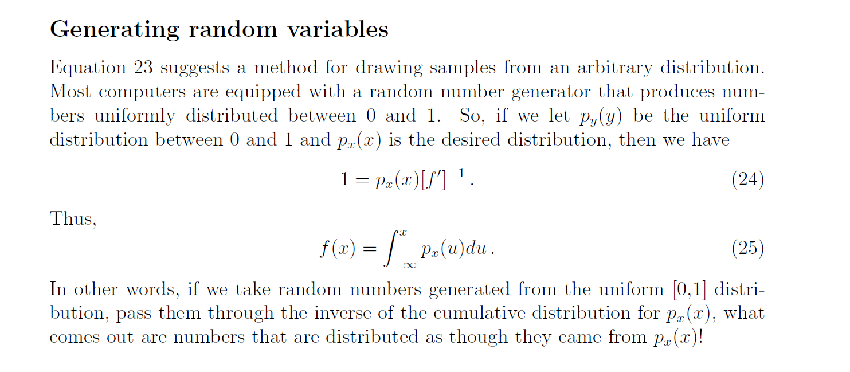
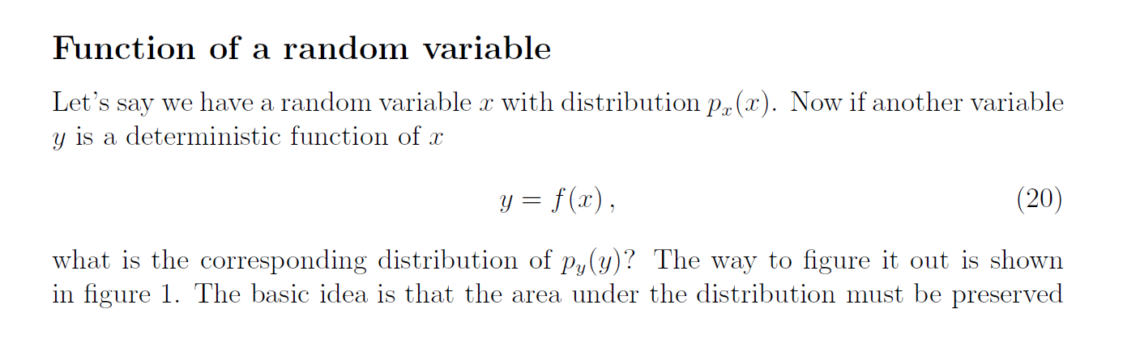
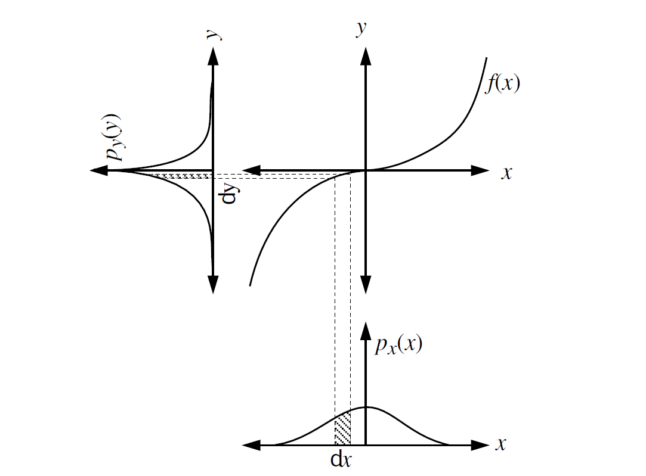
Figure 1: Distributions px(x) and py(y) must have equal area for corresponding intervals.
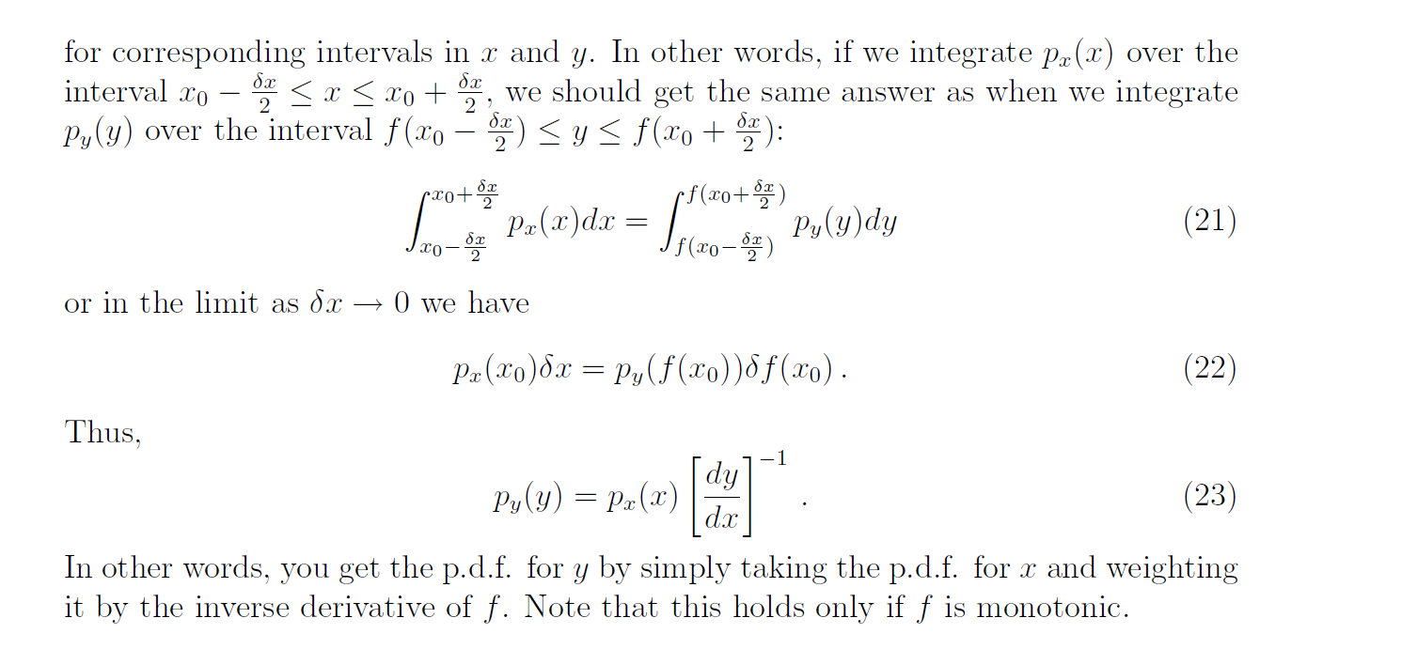
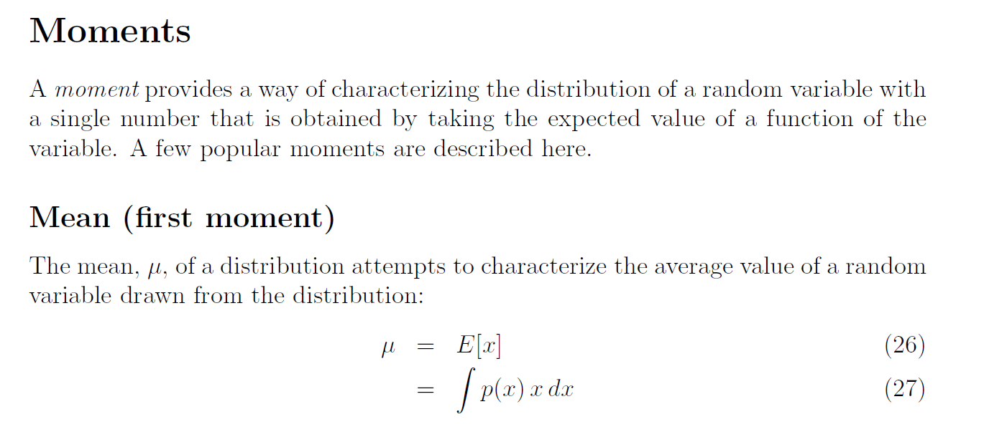
where E[] denotes “expected value.” Note that for some distributions—e.g., a bimodal
distribution—the mean does not in any sense characterize the typical value of
a variable drawn from the distribution.
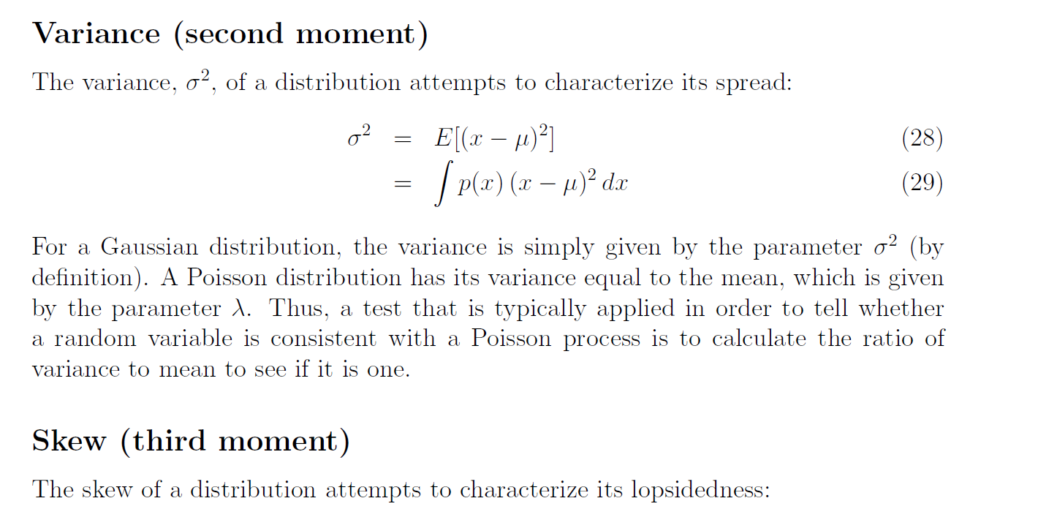

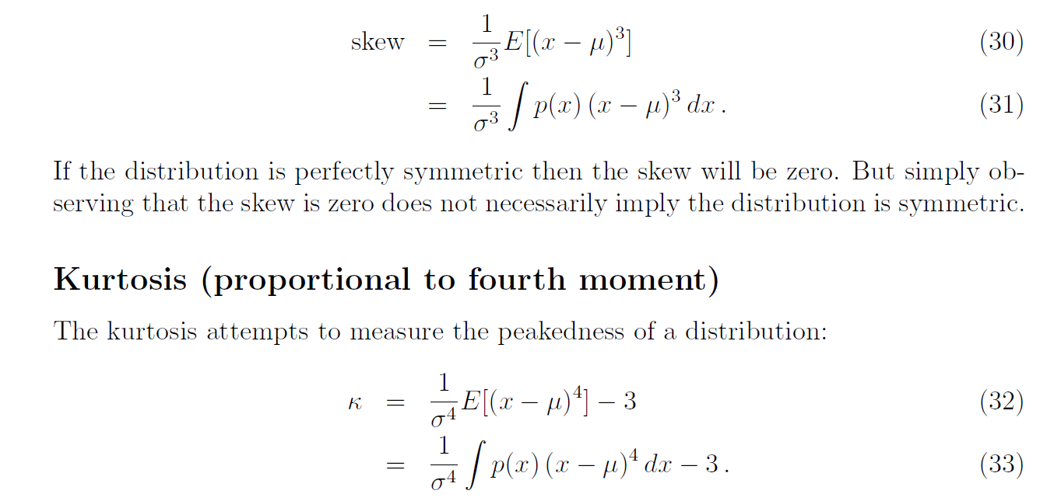
The reason for subtracting three is so that _ = 0 for a Gaussian distribution. A
distribution with positive kurtosis may be more peaked or have heavier tails than a
Gaussian, while a distribution with negative kurtosis may look more like a loaf of
Bread.

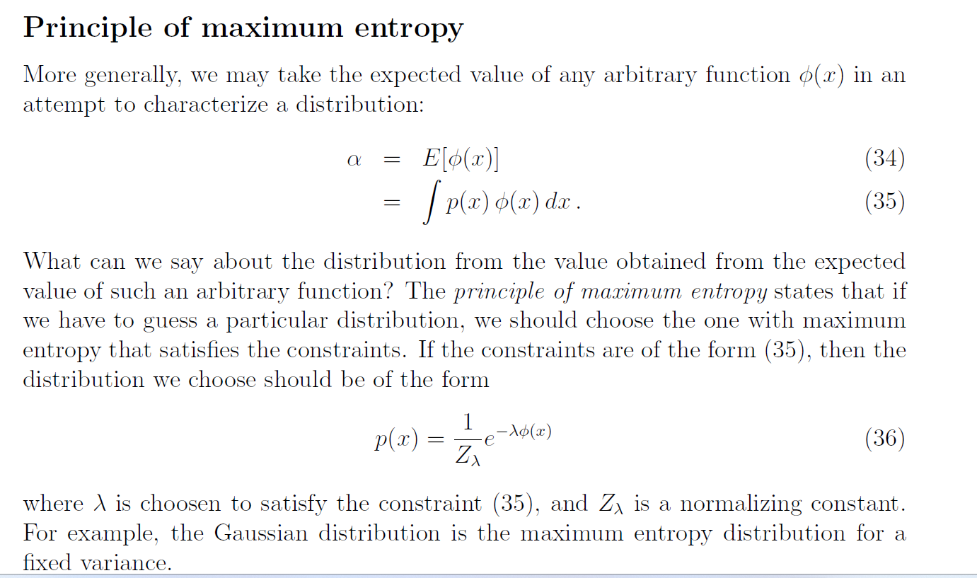

EXPLAINATION:
The principle of maximum entropy is a concept in probability theory and information theory that suggests a way to choose a probability distribution that is consistent with certain constraints while maximizing the overall uncertainty or entropy of the distribution. This principle is often used in cases where we have limited information about a system but want to make the least biased or most conservative probability distribution assumption.

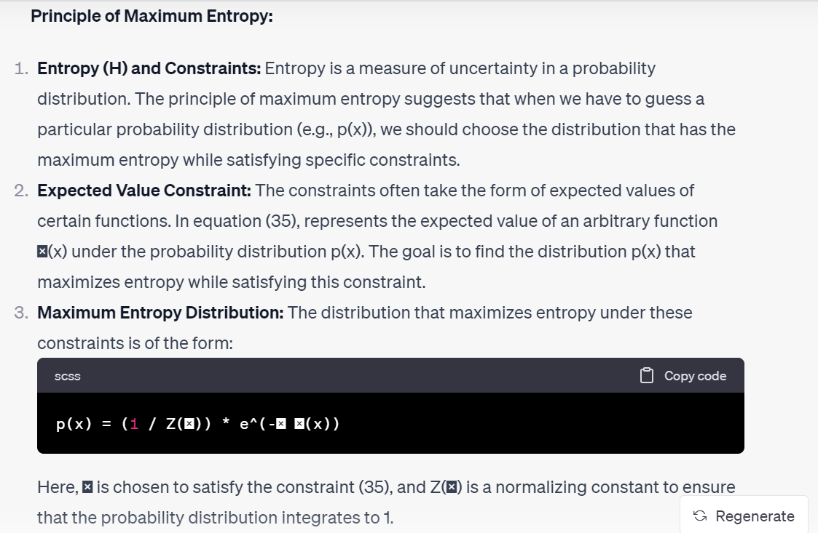

Example: Gaussian Distribution and Maximum Entropy:
Let's consider an example of the Gaussian distribution, also known as the normal distribution. The Gaussian distribution is often encountered when dealing with real-world data, and it can be derived using the principle of maximum entropy.
Suppose you know the mean (expected value) of a random variable X but have no information about its probability distribution other than that. You want to find the distribution that maximizes entropy under the constraint that the mean of X is known.
The maximum entropy distribution under this constraint is the Gaussian distribution. The Gaussian distribution has the highest entropy among all distributions with a fixed mean and variance. It has the form:

LECTURE # 05: LINEAR ALGEBRA PRIMER:

A tensor is a mathematical object that generalizes scalars, vectors, and matrices to higher-dimensional spaces.

